Feature - Centralized API Keys

Table of Contents
• Introduction
• Setup Azure AD / Entra ID
– Step 1: Creating AI Administrators Group
– Step 2: Granting Access to AI Administrators Group
– Step 3: Creating the Azure Key Vault
– Step 4: Store Secrets in Key Vault
– Step 5: Creating AI Users Group
– Step 6: Granting Access to AI Users Group
This feature is available starting from version 1.11.06.

Introduction
This document provides a step-by-step guide on setting up centralized API keys in Azure AD / Entra ID for the OpenAI and AI Speech services. This ensures that only specified users and invited guests can access the necessary API keys stored in an Azure Key Vault.

Setup Azure AD / Entra ID

Step 1: Creating AI Administrators Group
Optional step: If you don’t have the correct permissions to create a Key Vault or manage keys, secrets, and certificates, you can create an ‘AI Administrators’ group and assign the required roles and members to it.
1. Navigate to Azure AD / Entra ID:
– Go to the Azure portal.
– Select Azure Active Directory from the left-hand menu.
2. Create a New Group:
– In the Azure portal, search for Groups service.
– Click on the Groups menu item.
– Click on the + New Group button.
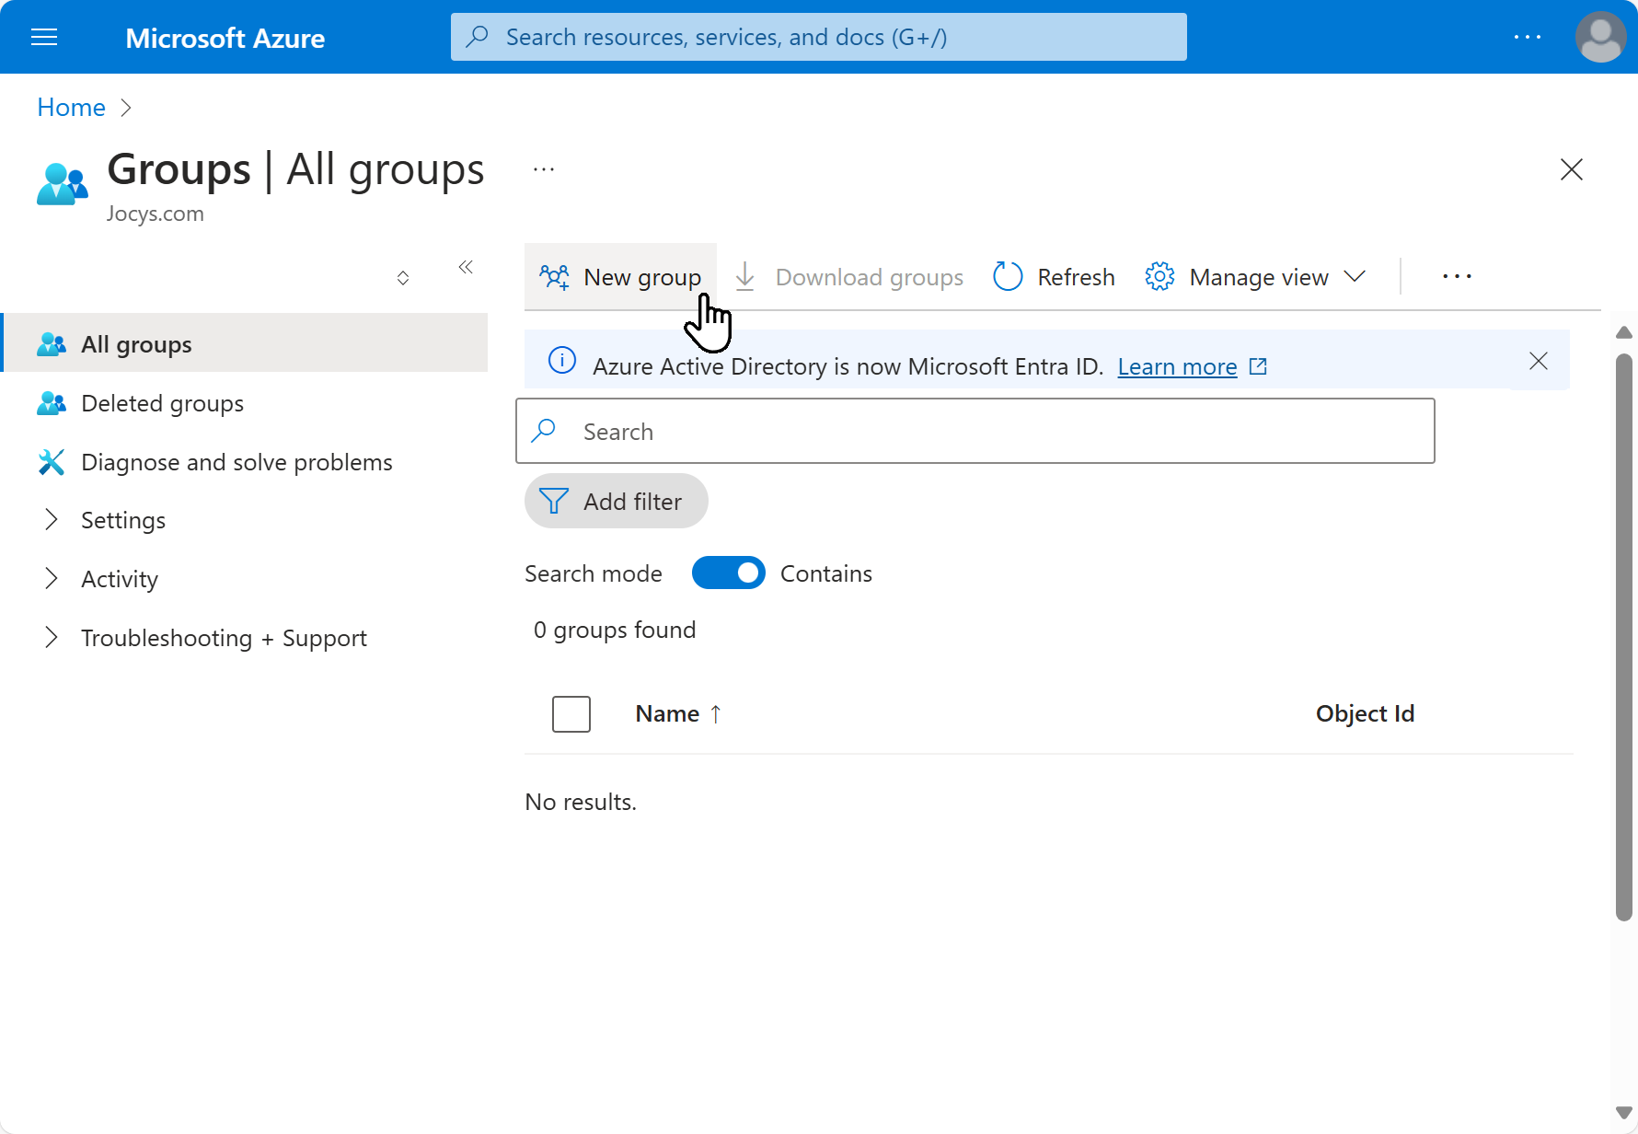
3. Configure Group Details:
– Group Type: Security
– Group Name: AI Administrators
– Description: Users that manage Key Vaults, OpenAI, and AI Speech service API keys.
– Membership Type: Assigned
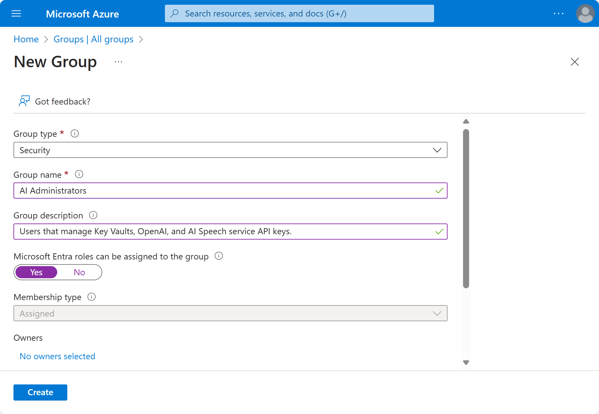
4. Add Members to the Group:
– Click on No members selected.
– Search for and select users to add to the group.
– If there are invited guest users, ensure they are also added to the group.
5. Create the Group:
– Click on the Create button to finalize the group creation.

Step 2: Granting Access to AI Administrators Group
You can grant access at the subscription, resource group, or directly on the Key Vault. The following steps show how to grant access at the subscription level.
1. Navigate to the Subscription:
– Go to Subscription in the Azure portal.
– Click on subscription where you plan to store API keys. For example: sub-prod-001.
2. Configuring Access control (IAM):
– Click on Access Policies (IAM).
– Click on + Add, then + Add Role Assignment.
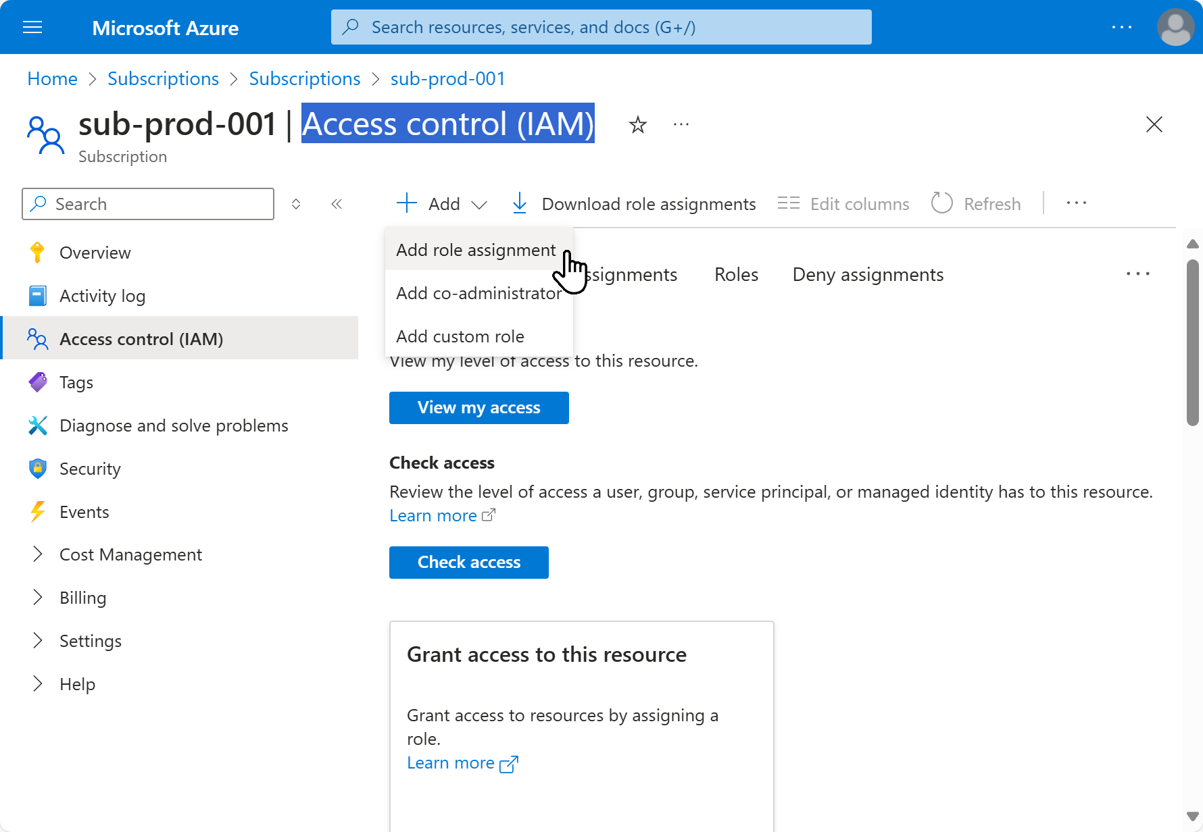
3. Configure Access Policy:
– Configure the access policy:
– Role: Search and select Key Vault Reader role. Press [Next].
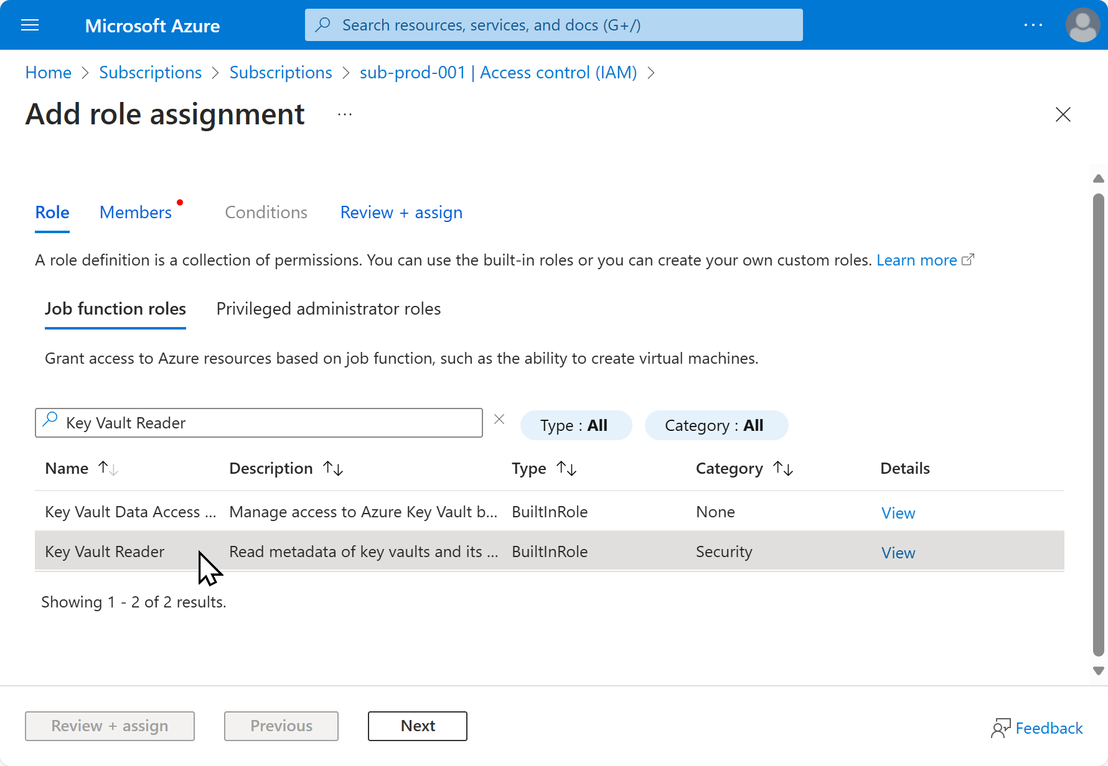
– Members: Select User, groupp or service principal, click + Select members and add AI Administrators group.
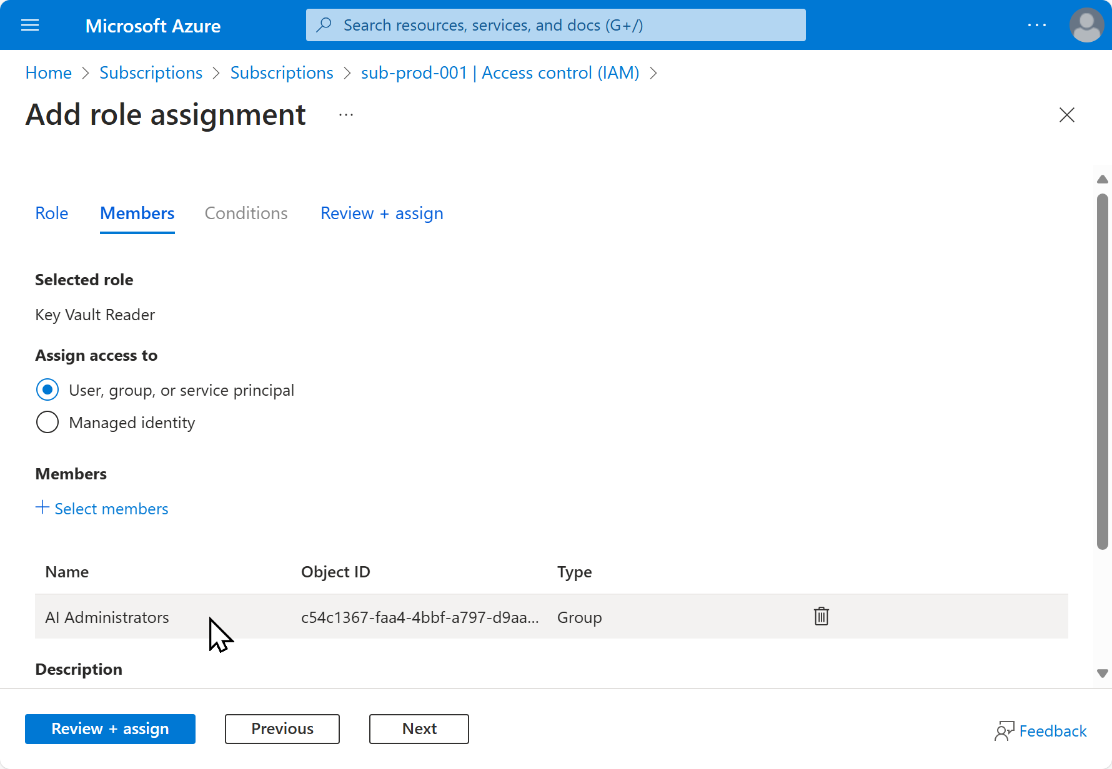
4. Save the Access Policy:
– Click on [Next] and then [Review + assign] to apply the access policy.
5. Grant Full Access:
– Repeat Steps 2-4 to grant the AI Administrators group the following roles:
• Key Vault Contributor
• Key Vault Administrator
• Key Vault Crypto Officer
• Key Vault Certificates Officer
• Key Vault Secrets Officer

Step 3: Creating the Azure Key Vault
1. Navigate to Key Vaults:
– In the Azure portal, search for Key Vaults and select Key Vaults.
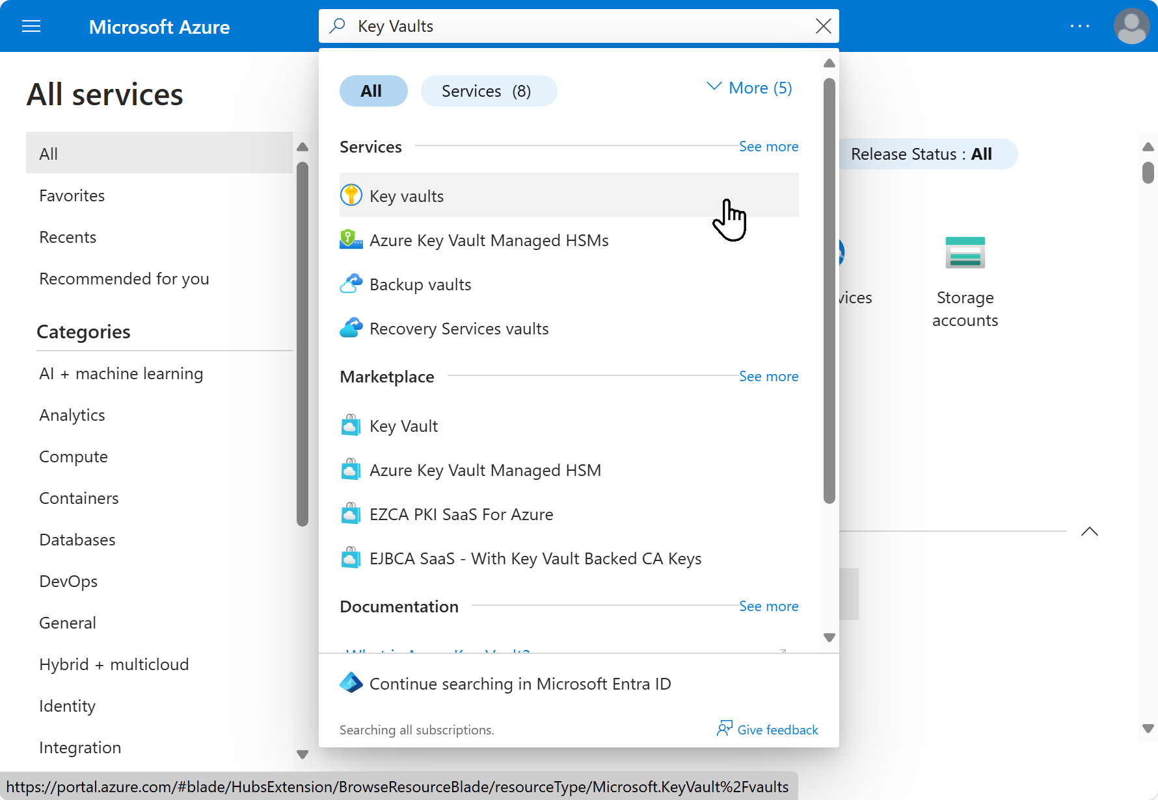
2. Create a New Key Vault:
– Click on the + Create button.
3. Configure Key Vault Basics:
– Subscription: Select your subscription.
– Resource Group: Select an existing resource group or create a new one.
– Key Vault Name: company-ai-api-key-vault
– Region: Select the region closest to your users.
– Pricing Tier: Standard
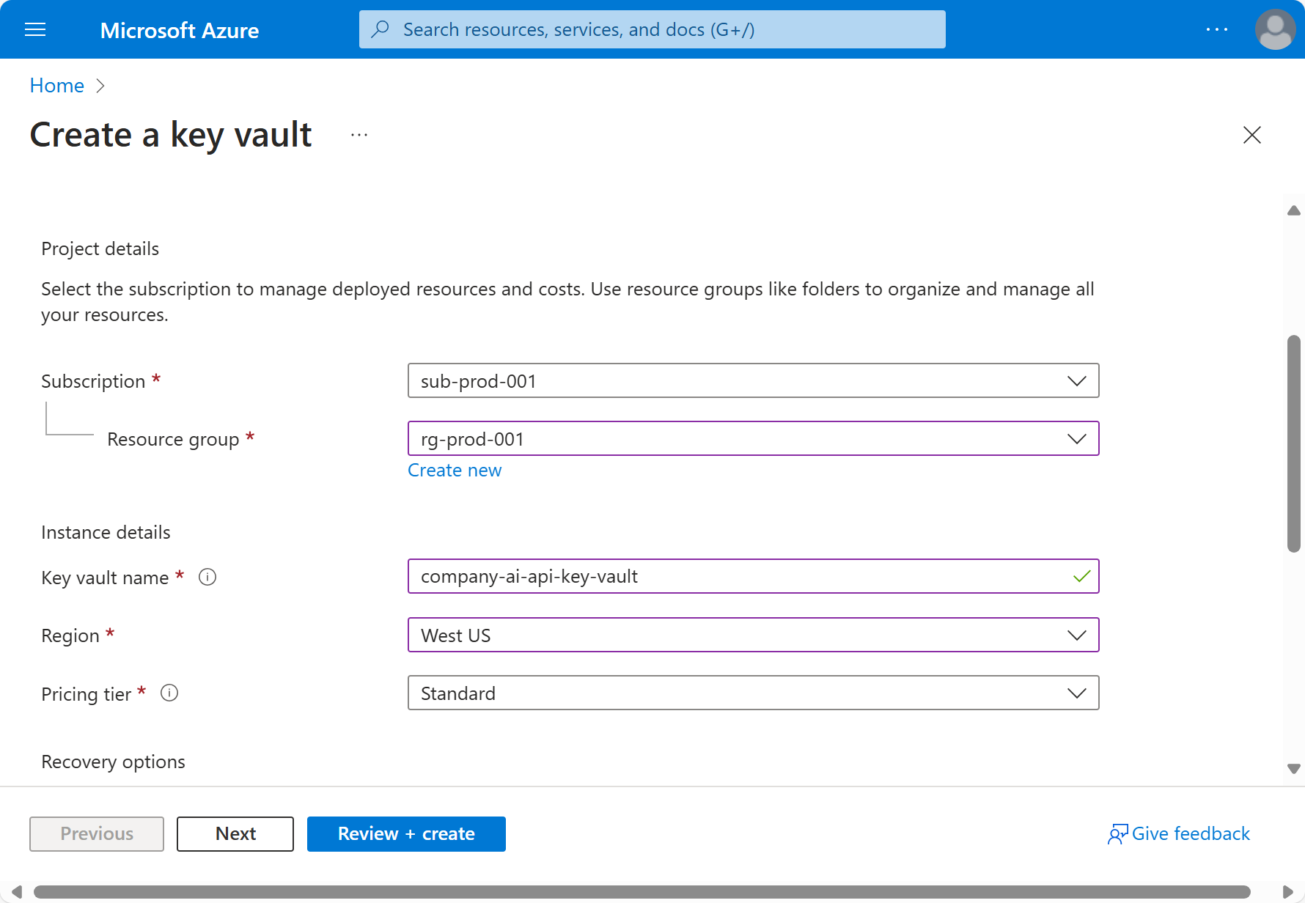
4. Review and Create:
– Click on Review + create.
– After validation, click on Create.

Step 4: Store Secrets in Key Vault
1. Navigate to the Secrets Section:
– In the Key Vault (company-ai-api-key-vault), click on Secrets.
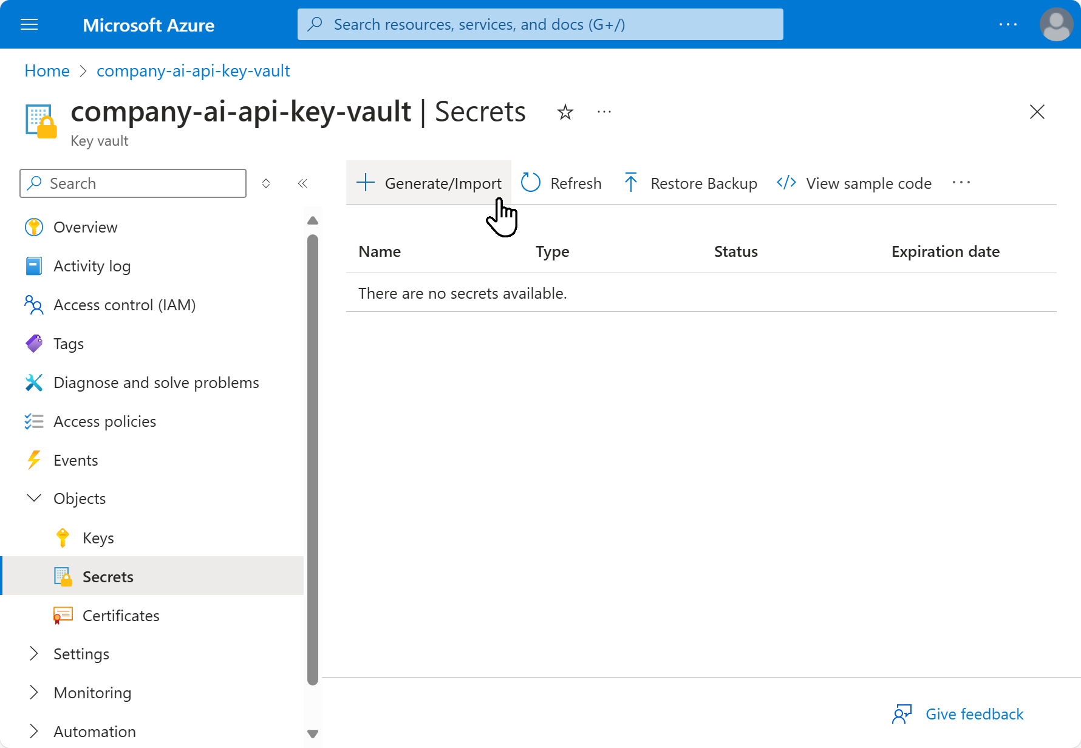
2. Add New Secrets:
– Click on + Generate/Import.
– Secret Name: openai-api-key
– Value: (Enter the OpenAI API key)
– Click on Create.
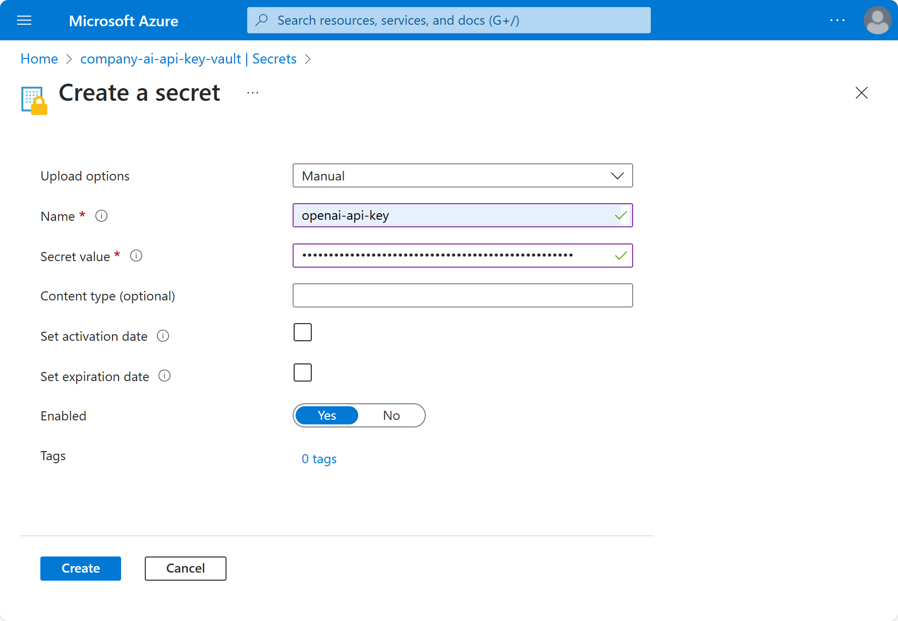
Repeat the process to add:
– Secret Name: ms-speech-service-api-key
– Value: (Enter the AI Speech service API key)

Step 5: Creating AI Users Group
1. Navigate to Azure AD / Entra ID:
– Go to the Azure portal.
– Select Azure Active Directory from the left-hand menu.
2. Create a New Group:
– In the Azure portal, search for Groups service.
– Click on the Groups menu item.
– Click on the + New Group button.
3. Configure Group Details:
– Group Type: Security
– Group Name: AI Users
– Description: Users who need access to OpenAI and AI Speech service API keys.
– Membership Type: Assigned
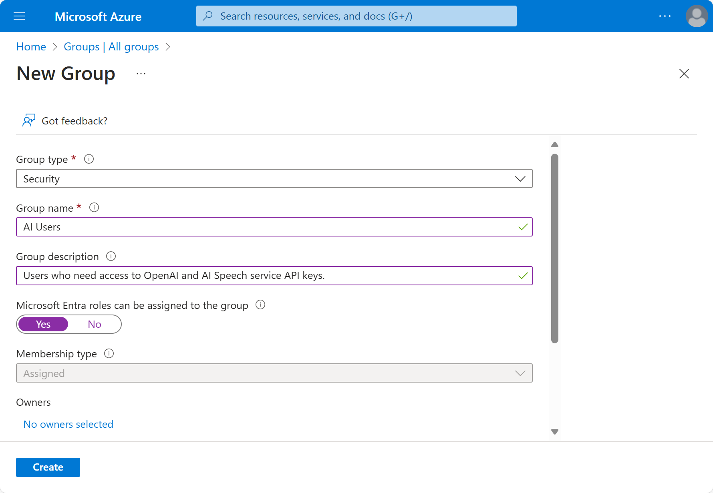
4. Add Members to the Group:
– Click on No members selected.
– Search for and select users to add to the group.
– If there are invited guest users, ensure they are also added to the group.
5. Create the Group:
– Click on the Create button to finalize the group creation.

Step 6: Granting Access to AI Users Group
1. Navigate to the Key Vault:
– Go to Key Vaults in the Azure portal.
– Select company-ai-api-key-vault.
2. Add Access Policies:
– In the Key Vault settings, click on Access Policies.
– Click on + Add, then + Add Role Assignment.
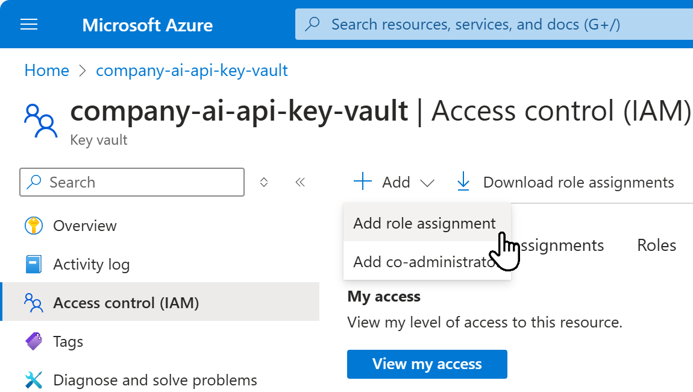
3. Configure Access Policy:
– Configure the access policy:
– Role: Search and select Key Vault Reader role. Press [Next].
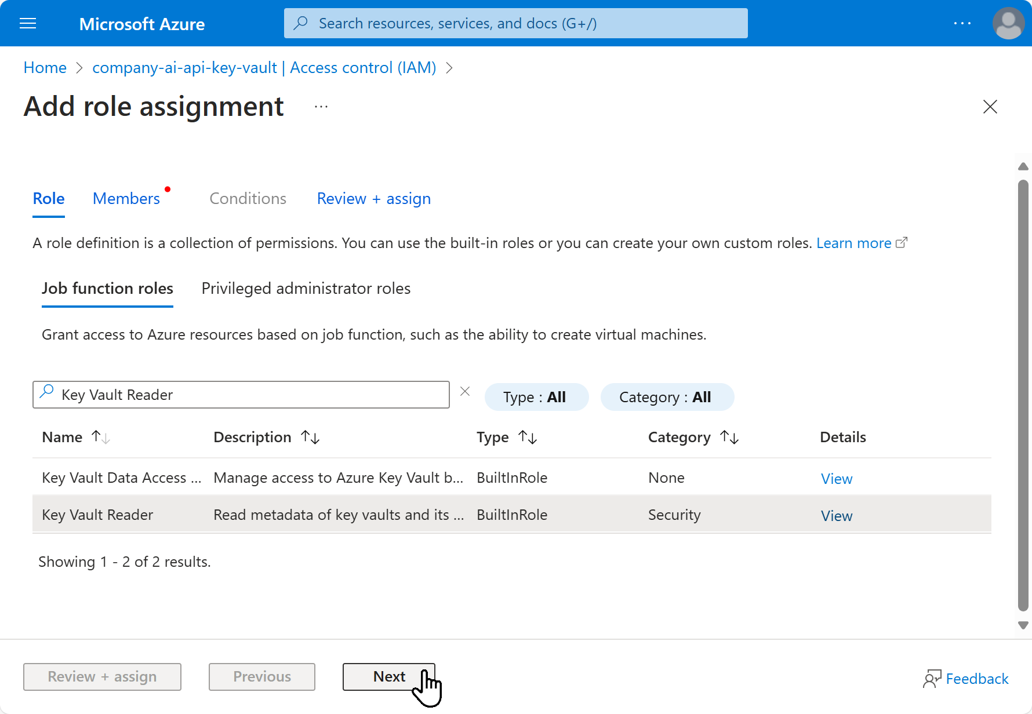
– Members: Select User, groupp or service principal, click + Select members and add AI Users group.
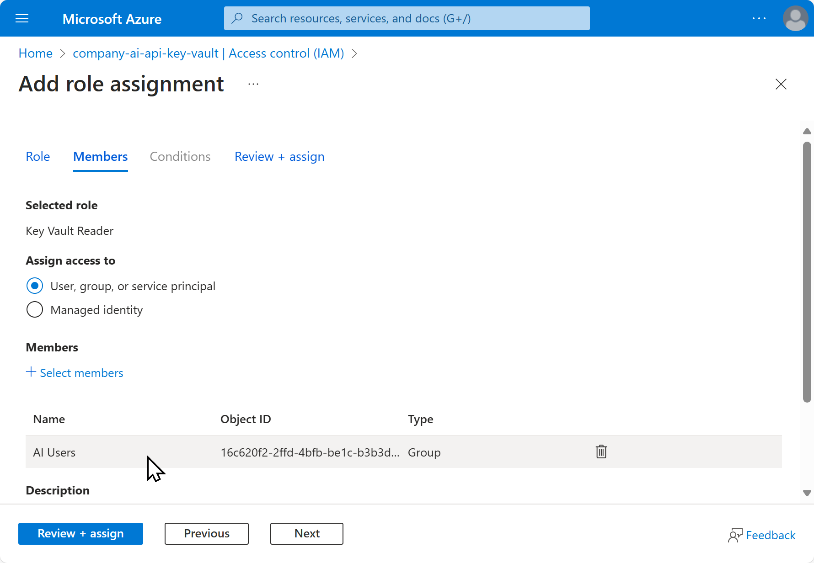
4. Save the Access Policy:
– Click on [Next] and then [Review + assign] to apply the access policy.

